Day 3 Lab Assignments
Use CSS and CSS3 styles to do the following:

- Make a div with a rounded border and write your name on it and make it appears vertical on the page (use transform).
Like the following image:


- Make a simple photo gallery, and use the transition to make the photos zoom outs with animation on hover (Use transform: scale() with transition).
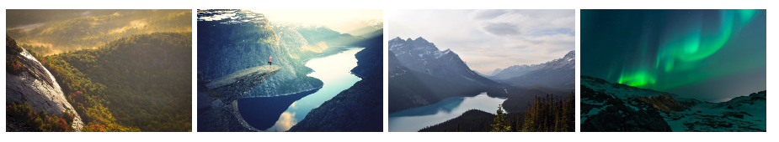

- Use CSS3 columns on any paragraph.

- Use animation to move a car from the start of the page to 1400px (horizontal).

Bonus:

1- Redo assignment 1 with text-shadow and new font from google fonts.

2- Make a navbar with rounded corners, and use Font awesome, to add some icons to the navbar items.

  - Use the icons from Font awesome.
  - Make the navbar items a list (ul), and inside each list item (li), add a link for each menu item.
  - Use list style type: none for the list items.
  - Use display: inline-block for the list items. (Why?).
  - Handle that when mouse over an item its background color is to be changed, and the icon color also to be changed gradually (Use transition).

<Thank>YOU </Thank>

